English

The Dream

K-droz Contest 2019

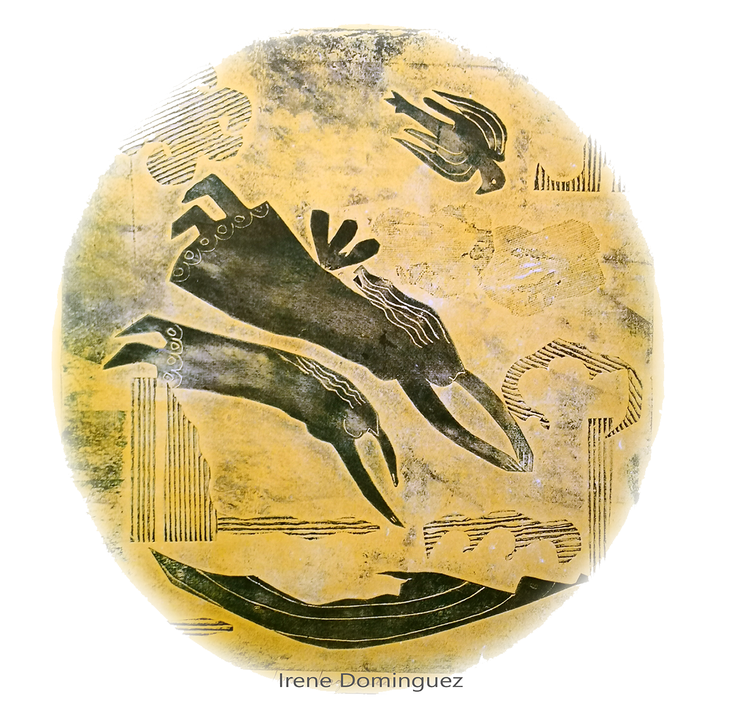

Word or Pdf file to be e-mailed to Lereve@k-droz.fr

by 31st March 2019.
The K-droz Association promotes ways for novelty in artistic creations, using contemporary materials and techniques. Since its creation it has organized six competitions :

- Triton d’Or, for cardboard works in 2013. 2015. 2017, Machine-made works of art in 2014, Kinetic art in 2016, Metamorphosis, for reclaimed material Art in 2018

These 6 contests have generated several exhibitions in Paris, Nancy in France, Hamm and Münster in Germany, London GB, Antikira in Greece.
Many artworks from these competitions and subsequent exhibitions have been acquired by collectors.

In 2019, the K-droz artistic association is organizing a new international contest placing the same emphasis on creativity.

Contest
The competition is open to all.
Applications will be received by E-mail at no charge.
The theme of the competition is The Dream, the presented work will attract the viewers into dreaming.
The choice of techniques is open, in a contemporary framework.
Videos and literary works are not accepted for this contest..
The submitted piece of artwork should relate to theme of dreams and dreaming.
The selection of the winners will be based on:
- Novelty of the presented work : concept, strength, aesthetics
- Quality in its making
- The artist`s commitment to the artistic creation.
The jury, whose decision is final, will be comprised of artists, visual art experts and curators chiefly :
- James Chedburn, visual artist
- Serge Plantureux, Art publisher
- Pierre Chirouze, President of the K-droz artistic association
- Jean-Marc Introvigne, curator
- Claudine Fournier, painter
- Gela Chmelar, curator
- Polyxene Kasda, visual artist
- Ange Pierraggi, painter
- Jean Lesage, art enthusiast
- Pascale Wirth, visual artist
- Antoine Bechara, visual artist
- Olivier Millerioux, visual artist
- Rafael Monreal, architect
The jury reserves the right to request additional information from applicants if required.
The overall winner will be awarded prize of 500 € by K-droz.
Up to 10 artists will be commended and receive acknowledgement of their work with media coverage in several countries and an exhibition of the photos in a gallery in Paris, France.
Application procedure

For practical reasons, the application for the contest is based on photos supplied by the artist / candidate. Picture quality is therefor essential.
Every candidate must send a single Word or Pdf file of the completed form below.
The completed application form in Word or pdf format will include three parts :
- The application form duly filled.
- A picture of the presented work, in jpg format, 1 to 2Mb.
- 3 additional photos of recent works, 1 to 2Mb
The file should be e-mailed to Lereve@k-droz.fr by 31st March 2019.
The results of the contest will be made available on K-droz’s site from 8th April 2019.
K-droz and its sponsors retain the right to use the photos sent by the candidates and will credit the artist at all times. The images will be used for the promotion of the artist and the association an will not be used for commercial purposes.
For additional information, write to contact_2@k-droz.fr
Website for the contest

Application form
DEADLINE 31st March 2019– Pdf or Word format – Lereve@k-droz.fr
Presentation of the candidate

Name – First name | E-mail address | Phone | Year of birth | City of residence, Country
Artist’s background text, 100 words max

Presentation of the work
Title of work | Year of creation | Size H x W x D, cm Weight, kg | Value, € | Type (Sculpture, installation, …)
Artistic approach to this work, 100
words max

Please insert 3 photos of the past works, 2 MB max, the title, dimensions and technique of each photo should be included.
I declare that I have read the contest information and rules an certify this work is original and my own production
Competition website
For further information, please contact us at: contact_2@k-droz.fr
I fully accept the rules for this contest.
Statement
Please fill in and sign:
I, (...), declare that I have taken account of the K-Droz reclaimed material art contest and certify the accuracy of the information provided in this file.
Date and place, write “read and approved”, artist’s signature

