Sport
The art of movement
K-droz competition 2024

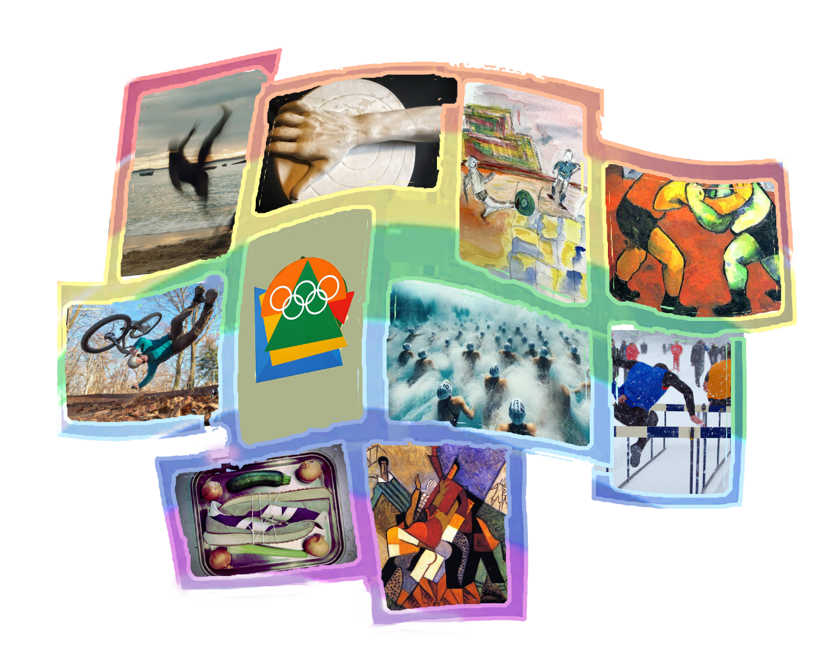

Deadline: April 28, 2024 – Word or compatible format to be sent to sport@k-droz.fr

Since its founding in 2006, the K-droz association has promoted innovative artistic creations. Contemporary technologies and original themes have been featured in 11 competitions:
2013, 2015, 2017, the Triton d’Or, cardboard works, 2014 3D printing, 2016 Kinetic art,
2018 Metamorphosis, 2019 The Dream, 2020 The Woman of the 21st century, 2021 Blue, 2022 Children's drawings and 2023 Reconstruction.

All these competitions were awarded prizes and distinctions and generated several exhibitions in Europe: Paris, Nancy, Veules (France); Hamm, Münster (Germany); Antikira, Samothrace (Greece); where several pieces found their place at art collectors.
The 2024 competition with the theme of Sport is the latest in this line of artistic competitions.

The competition
The competition is open to all.
Applications are received online, free of charge.
Candidates must represent objects, scenes or environments representing or evoking sport.
The participant is free to choose any contemporary techniques in visual arts (excluding video and performance).

The selection of winners will be based on the following criteria:
- The originality of the work presented: concept, strength, aesthetics.
- The quality of its production
- The commitment, approach and intentions of the artist in his or her creation.

The jury, whose decisions are final, is made up of artists and prominent individuals from the visual arts:
- Pierre Chirouze, president of the K-droz artistic association
- Gela Chmelar, exhibition curator
- Claudine Fournier, painter, colorist
- Jean-Marc Introvigne, exhibition curator
- Polyksene Kasda, visual artist
- Rafael Monreal, architect
- Ange Pieraggi, visual artist, author
- Pascale Wirth, art teacher, painter
- Jöelle Zafrani, art teacher

The First Prize winner of the competition will receive €600.
Ten artists will receive an honorable mention which will give them priority access to opportunities offered by K-droz such as information, exhibitions and conferences, for one year.

The application file

The competition is based on the file presented by the artists and on photos of the work. The quality of the photos is therefore essential.

The application file will include: | Format
The form below, completed in | .doc ou .odt exclusively | as an attachment
Photo of the work responding to the competition, captioned with the name of the artist and title of the work. Eg. Jdacier-hurdle.jpg | .jpg | as an attachment from 1 Mb to 2Mb
3 photos of other works of the artist | .jpg, attached | as an attachment 1Mb to 2Mb each

to be sent by email to the following address sport@k-droz.fr no later than April 28, 2024.

The results of the competition will be announced on May 4th, 2024 on the K-droz website.
The photos sent by the candidates may be used by K-droz and the sponsors of this competition, with mention of their name. They will be free of copyrights and will be used to promote the artist and the K-droz Association.
K-droz and the sponsors are prohibited from making commercial use of these images.
Additional information is available by writing to contact_2024@k-droz.fr

- - - - - - - - - - - - - - - - - Next page APPLICATION FORM to detach - - - - - - - - - - - - - - - - -
THE SPORT
The art of movement
Art competition

To be returned before April 28, 2024 - Word or compatible format to sport@k-droz.fr

Presentation of the candidate

Last name – First name | Email address | Telephone | Year of birth | City of residence, Country
Site web ou bio de l’artiste
( 50 mots max)

Artist’s website or bio (50 words max)

Presentation of the work

Title of the work | Year of creation | Dimensions h x l x d, cm  sculpture: weight, kg | Value € | Type (Painting, Sculpture, Photo, etc.)
Artistic approach for this work, 100 words max

I declare on my honor that the work presented for this competition is an original and personal creation and that the work really exists.
I accept the rules of the Sport competition organized by K-droz.
I, the undersigned (…), declare that I have read the Reconstruction competition and certify the accuracy of the information provided in this file.

Date and place, “read and approved”,
Signature of the artist

