CHILDREN'S DRAWINGS
A source of inspiration
K-droz 2022 art competition

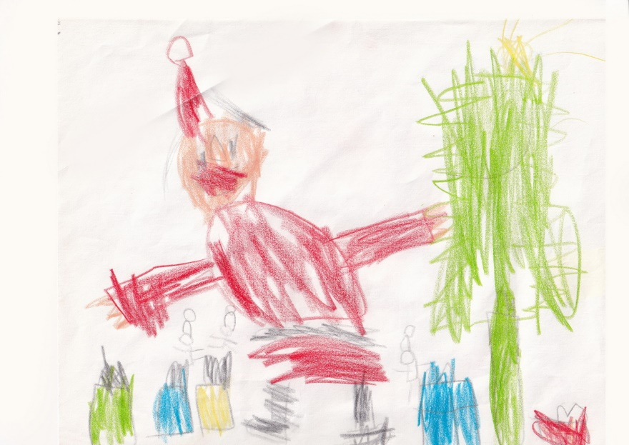

Application deadline: April 18, 2022 - Word format or compatible to send to dessinsdenfants@k-droz.fr

Let's be inspired by children's spontaneity and creativity!
This year, K-droz invites you to take part in our competition by producing an original piece of work inspired by one of the 49 children’s drawings we have compiled.

The competition
The competition is open to everyone, free of charge.
Applications should be sent via email.
The proposed works will be inspired by the children’s drawings found at
http://www.k-droz.fr
Applicants can choose any technique in plastic arts: painting, sculpture, photography, graphic creation, installations. This contest however excludes videos and performances.

The winners will be chosen on the following criteria:
1 -The originality of the work presented: sublimation and going beyond the model, aesthetics
2 -The quality of the finished piece
3 - The artist’s commitment, approach and intentions in his creation.

The panel of judges is independent and made up of artists and experts from the visual arts:
- Pierre Chirouze, President of K-droz Association artistique
- Jean-Marc Introvigne, exhibition curator
- Claudine Fournier, Painter
- Gela Chmelar, exhibition curator
- Polyksene Kasda, visual artist
- Ange Pieraggi, visual artist, writer
- Pascale Wirth, Painter
- Rafael Monreal, Architect
- Jöelle Zafrani, art Teacher
The winner of the Children's Drawings, 2022 competition will receive a prize of 600€.
Ten artists will receive a honourable mention and may be invited to take part, if the circumstances allow, in an exhibition of their pieces or their photographic reproduction to be organized in Paris and/or in another European country.

The application file
The judges’choices will be made on the basis of files and photographs of the work presented, sent by email.
The quality of the photos is therefore essential.

The application package will include: | Format
The form below, completed | .doc or .odt attachment
Photo of the submitted piece, captioned with the artist's name and title of the work.  eg. JLaurence-sincerityjpg | .jpg  attachment | 1MB to 2MB
3 photos of other pieces from the artist’s portfolio | .jpg  attachment | 1MB to 2MB

Applications will be sent by email to the following address:
dessinsdenfant@k-drozfr no later than April 18, 2022.
The results of the competition will be announced after April 26, 2022 on the K-droz website.
The photos sent by the candidates can be used by K-droz and the sponsors of this competition, with mention of the photographer’s name; these will be free of copyrights. They will be used to promote the artist and the K-droz Art Association.
K-droz and the sponsors agree not to use them for commercial purposes.
For additional information, write to contact_2@k-droz.fr

Application form detachable
CHILDREN'S DRAWINGS
K-droz 2022 art competition
Candidate presentation
Name - First name | E-mail address | Telephone | Year of birth | City of residence, Country
Artist’s bio
50 words max

Presentation of the work
Number of the chosen drawing | Title of the piece |  | Year of creation | Dims h x l x d, cm Weight,kg | Value € | Type (painting, sculpture, ...)
Artistic intention for this work,
50 words max
I declare on my honour that the work submitted for this competition is an original and personal creation and that the work actually exists.
I fully accept the rules and apply for the competition organized by the K-droz association.
Certificate
To be completed and signed:
I, the undersigned (...) declare that I have read the Children’s Drawings competition and certify the accuracy of the information provided in this file.

Date and place, Mention "read and approved", Signature of the artist

Links

Websiste of K-droz association artistique
Presentation of K-droz association artistique

Charitable contribution

A non-profit association, K-droz is promoting a charitable fundraiser for the benefit of childhood. Applicants
may contribute freely to Pour un Sourire d´Enfant (PSE)
For information and to donate https://www.pse.ngo/i-give

A short history of the K-droz competitions

Since its founding in 2006, the K-droz association has made it its mission to promote paths of original artistic creation. Contemporary materials and technologies have been featured in 9 competitions:
- the Triton d´Or, works made of cardboard in 2013, 2015, 2017, production of works of art in 3D printing in 2014, kinetic art in 2016, Metamorphosis, recycled materials in 2018. 2019 saw a competition on the theme Le Rêve, and 2020 La Femme du 21ème siècle. Blue, the 2021 competition is also in this lineage.
These competitions have generated exhibitions in Paris, Nancy, Hamm, Münster (Germany), London, Antikira (Greece), where several of the distinguished works have found their place among collectors.
Since their inception in 2013, the 9 K-droz competitions have attracted nearly 1,000 applicants, 9 First Prizes have been awarded and around 100 artists have been distinguished.

